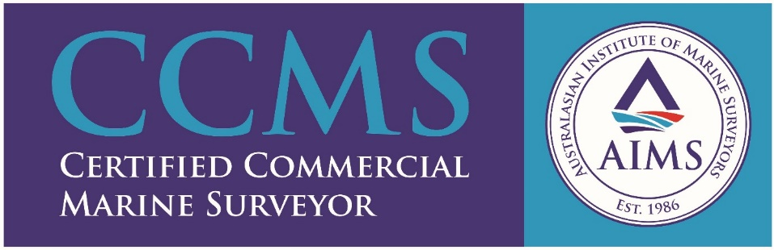
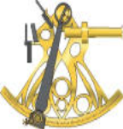
ACME MARINE SERVICES INTERNATIONAL Pty Ltd – Company Profile
ACME – From the ancient Greek word “akme/aekmi” to mean the “highest level of perfection, the peak, zenith, prime, etc”.
Acme Marine Services International Pty Ltd, a Western Australian owned and operated marine and cargo surveying company, was established and commenced operating as at 1st February, 2005, to service the marine industry, with regards to the provision of a wide range of marine and cargo-related survey services and associated activities.
Acme Marine Services International Pty Ltd was founded on the basis of providing a totally independent, reliable and professional service to all that are directly or indirectly active within the marine industry.
Although based in Fremantle, Western Australia, we can offer our services, as per our Clients’ needs, to all ports and other locations within Western Australia, together with attendances elsewhere in Australia and abroad, if required.
Acme Marine Services International Pty Ltd has grown from strength to strength over the years, since inception, servicing Clients/Principals not only based locally or interstate but also internationally.
All our marine surveyors are members of the Australasian Institute of Marine Surveyors (AIMS) and we undertake our marine survey work in accordance with the “Code of Conduct”, as maintained by the AIMS.
Our “List-of-Marine-Surveys-and-Services” are available upon request.
Contact Details
Capt. Michel Lagesse – (MAIMS, MNI) - Managing Director/Principal Marine Surveyor

P O Box 1200, Fremantle, WA, 6959
PH (1): +61 (0)8 9438 3888 (Office Hours)
PH (2): +61 (0)8 9339 1094 (After Hours)
FAX: +61 (0)8 9339 1096
MOB: +61 (0)429 391 094
EMAIL: operations@acmemsi.com.au General/Operations)
EMAIL: michel@acmemsi.com.au(Personal)
SKYPE: mclagesse1
WEBSITE: www.acmemsi.com.au

