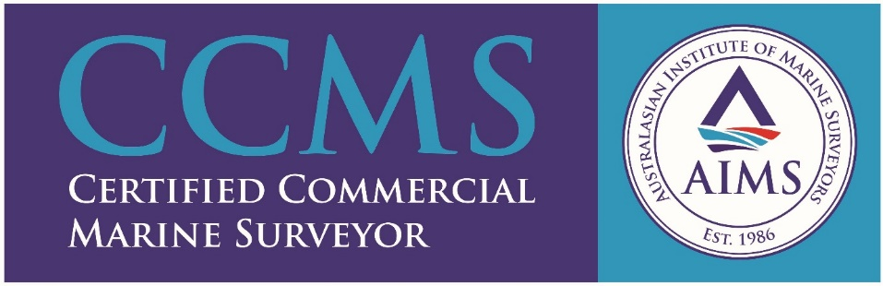

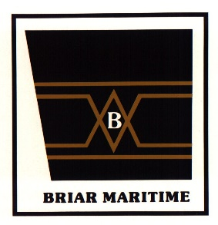
Briar Maritime

Founded in January 1986 by two Master Mariners, Briar Maritime provides the full spectrum of marine surveying services, training & consultancy to our clientele, both local and international.

There are four Master Mariners and other personnel certified by DAWR. We provide bulk vessel inspections and inspection services for the export of forestry products for DAWR. We have a launch in three Tasmanian ports for draft surveys.

We have a high safety culture and our personnel do not hang over the ship side on rope ladders or swing from bosun chairs on the provision crane. We are AMSA Accredited Surveyors and perform surveys under the NSCV. We are licensed certifiers with the NMI and provide metrology services (meter proving) to the downstream oil industry, including storage tank calibration and oil loss control consultancy. A tanker safety training package is accredited by AMSA under STCW95 and is delivered regularly to ship staff, the RAN and associated shore trades.

Pre-purchase surveys & valuation of both commercial and recreational craft is provided for owners & insurers. Compass adjusting up to 35M. Container inspection, lashing and OOG surveys are also a part of our suite of services. We do not perform surveys on machinery.

