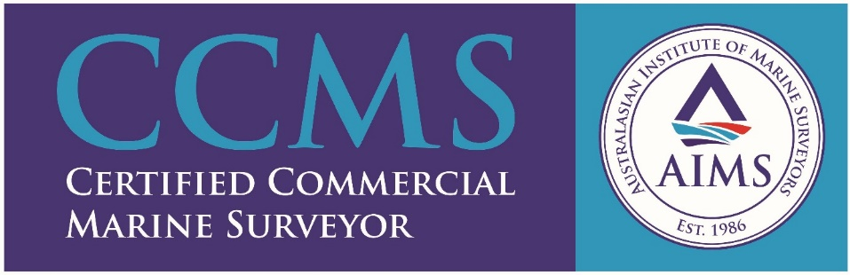
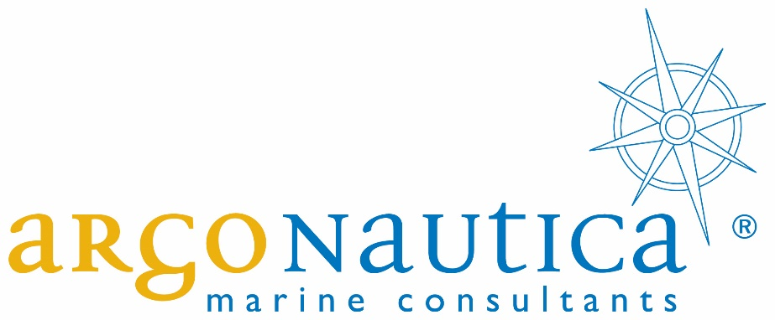

Argonautica Marine Consultants– Company Profile

Argonautica is a well-established proven independent marine consultancy to the shipping, ports and offshore oil and gas industries. We combine marine regulatory knowledge with practical operational and technical expertise to provide a unique range of survey and consultancy services.

Craig Harrison is the Director of Argonautica; he has over twenty years of experience in the international maritime and oil and gas sector with 15 years specialising in project delivery for both EPCM and EPC organisations.

Craig is an Incorporated Engineer, an active member of the Institute of Marine Engineering, Science and Technology and Australasian Institute of Marine Surveyors and has worked for oil majors, EPC Contractors, as a Classification Society surveyor and an independent consultant. He has previously been a member of the technical panel for the Office of the Chief Investigator (OCI) in Victoria and the National Offshore Petroleum Safety and Environmental Management Authority (NOPSEMA) and is currently registered with the Australian Maritime Safety Authority technical advisory panel.

Craig Harrison
Director / Principal Consultant
Argonautica Pty Ltd
Office +61 3 9761 7626
Mobile +61 417 058 578
https://www.linkedin.com/in/craig-harrison-54143448
9 / 143 – 145 Canterbury Road Kilsyth Victoria 3137 Australia
P.O. Box 7426 Upper Ferntree Gully Victoria 3156 Australia
www.argonautica.com.au

