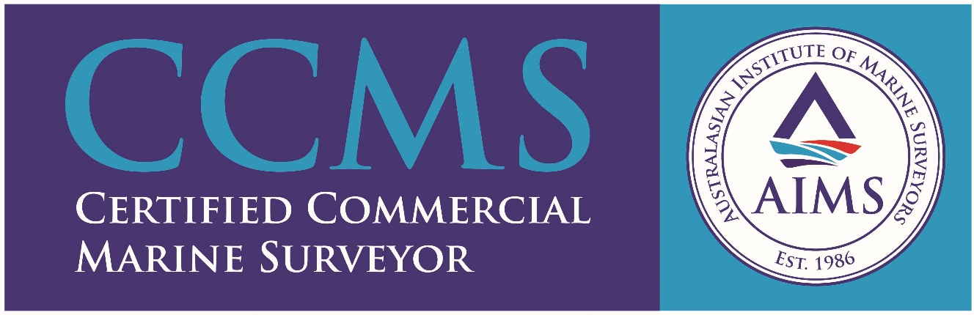
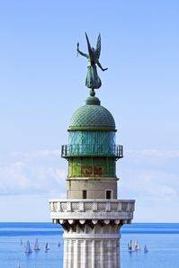
81 Bowker St, Warradale SA 5046

Email: sergio@faromarineservices.com.au
Website: http://www.faromarineservices.com.au/

Phone: +61 (08) 8298 2718
Mobile: +61 (0)411 068 945

Faro Marine Services Pty Ltd, a South Australian owned and operated marine and cargo surveying company, was established in 2000 with the aim to provide an independent professional service within the maritime industry. This it achieved and it has further developed over almost 20 year into a trusted, reliable, efficient company that values the knowledge and experience it holds but which is constantly learning and adapting to the needs and requirements of a changing industry.
Since inception the company has grown from strength to strength, not only servicing clients based locally and interstate but also internationally. For this reason, the company, although based in Adelaide, South Australia, can offer a full range of services to not only all ports and locations within South Australia, but also throughout Australia and abroad.
Sergio Mensitieri (son-in-law of Captain Aniello (Nello) Magliulo) has been with Faro Marine Services since February 2013 and was promoted to Operations Manager early in 2016. Sergio has taken over as Principal and Director of Operations for Faro Marine Services effective 1st July 2019, with Captain Nello retiring but providing ongoing support for the business in his role as expert marine consultant.
The business aims to maintain its strong family-based connections, with Paula Mensitieri (Captain Nello’s daughter) holding the Director of Business role as well as fully utilising Captain Nello's extensive knowledge with more than 40 years in the industry.
Faro Marine Services is ISO 9001:2015 accredited.

Services
The following services are conducted under Faro Marine Services Terms and Conditions which can be made available on request:
- Authorised Officer BVAR Surveys
- Grain Surveys
- Hatch Cover (Hose & Chalk) Testing
- Hatch sealing (Watertightness and security) Surveys
- Hold and Tank Cleanliness Surveys
- On/Off Hire Condition Surveys
- Bunker Surveys
- Draught Surveys
- Lashing/Securing Surveys
- Cargo Measurement Surveys
- Pre-purchase Surveys
- Cargo Condition Surveys
- Container Condition Surveys
- Ship Condition Surveys
- Bulk and Liquid Cargo Sampling
- Loadmaster/Cargo Superintendence
- P&I (Protection & Indemnity) Surveys and Investigations
- Supercargo and Shipping Superintendence
- Stockpile Measurement & Quantity Assessment
- Marine Surveyor Training (Cert IV accredited)

Team
DIRECTOR/OPERATIONS MANAGER/MARINE SURVEYOR
Mr Sergio Mensitieri
Mr Mensitieri was born in Italy from an extended family of Mariners and migrated to Australia in 1971. He speaks both fluent English and Italian.
Mr Mensitieri has been working as a surveyor with Faro Marine Services since the beginning of 2013.
By the end of 2014, Mr Mensitieri attained his Diploma in Marine Surveying from the Australasian Institute of Marine Surveyors. He also completed the DRY BULK UNIT giving him a specialisation in Grain Surveying and has been conducting Grain Surveys both at Anchorage and at Berth since January 2015. Mr Mensitieri is also an accredited authorised Officer for the Department of Agriculture having completed many hold inspections as an External AO.
Mr Mensitieri has received exclusive training from the previous Director and has performed a vast array of survey categories since his commencement of employment.
He was promoted to Operations Manager in February 2016 being responsible for all surveying work the company undertook. He has now become the Principal of the company as well as Director of Operations.
Memberships
AIMS – Member of Australasia Institute of Marine Surveyors

FREELANCE CONSULTANT
Captain Aniello (Nello) Magliulo
Obtained Master Mariner Class 1 (Foreign-Going) qualification 1968, serving on a wide variety of merchant vessels in worldwide trade, including general cargo, bulk carrier, refrigerated cargo, tanker, ro-ro and passenger liner.
Captain Magliulo migrated to Australia in 1974 and joined SGS Australia (formerly General Superintendence Company) in Sydney in June 1975 as Marine Surveyor.
In August 1979 Captain Magliulo moved to Adelaide as State Manager, covering also several senior management positions. In November 1996 Captain Magliulo joined ITS Caleb Brett as Marine Manager with the specific responsibility of P&I Surveys and Investigations, before forming and operating Faro Marine Services Pty Ltd. Captain Nello continues to be a valuable member of the team as an expert consultant in the field.
Captain Magliulo is an accredited grain surveyor.
Memberships
AIMS – Member of Australasia Institute of Marine Surveyors
CMMA – Member of Company of Master Mariners of Australia

