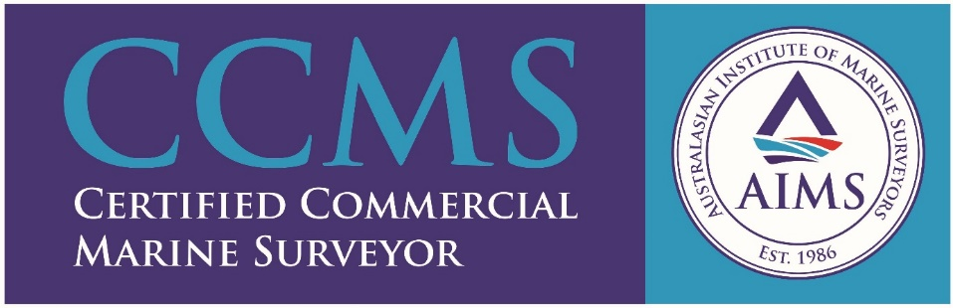
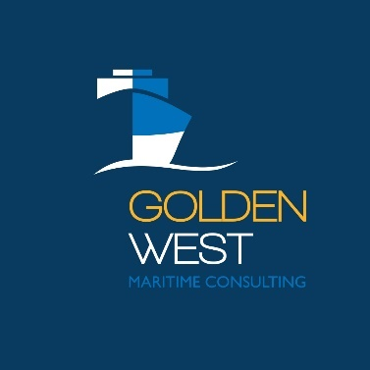
Golden West Maritime Consulting

Golden West Maritime Consulting offers a viable Marine Survey alternative for vessel owners operating in the regional areas of South Australia’s Eyre Peninsula, Far West Coast and beyond.
A wide range of survey options are available from small vessel Periodic and Safety surveys to bulk carrier Cargo Hold Inspections. Consultation for all your ISM Code (Safety Management System) and ISPS Code (International Ship & Port Security) implementation and auditing requirements is also available.
Damian Turner has over 20 years of seagoing experience. Since 2005 Damian has provided assistance with several sales and surveyed numerous vessels in Australia and Indonesia.
Damian’s education includes Bachelor of Applied Science (Marine Engineering), and Diplomas in both Marine Surveying and Coastal Marine Engineering. Seagoing certification is Engineer Class 2 (Steam & Motor), and Master <24M.
Maritime OHS, Confined Space Entry and Working at Heights licences along with MSIC are also currently held.
Damian is an AMSA Accredited Marine Surveyor (#107032), Engineering Technician
(Engineering Council), Associate Member of IMarEST, RINA and Member of
Australasian Institute of Marine Surveyors (AIMS).
Honesty, Integrity and Excellence are values you will find at Golden West.
‘Safe Solutions, Every time’

