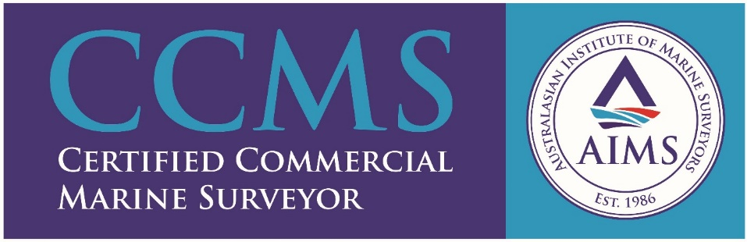

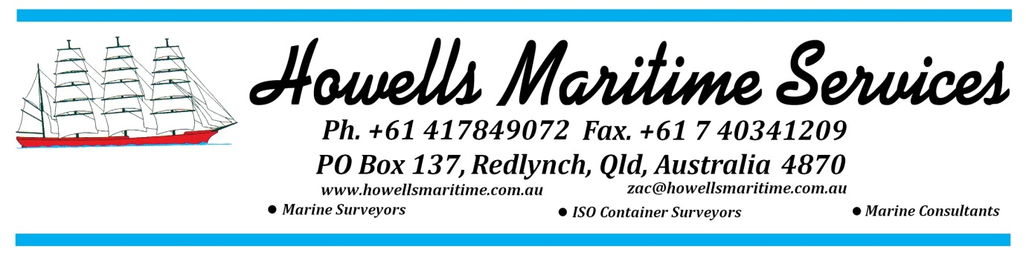

HOWELLS MARITIME SERVICES
Howells Maritime Services is a Company experienced in the marine industry. Established in 2006 and based in Cairns, Australia, proprietor Zac Howells is an AMSA Accredited Marine Surveyor, Bureau Veritas Accredited Container Surveyor, Panama Flag ASI surveyor and Belize Flag surveyor, who also offers invaluable hands-on expertise after 25 years as a boat builder and shipwright.
Zac has had experience with timber, fibreglass, steel and aluminium hull construction for surveys required for insurance, vessel damage assessment, cargo requirements and Statutory Survey requirements for Australian Commercial Operations under the Australian National System (AMSA).
Over the years Zac has been involved in project managing of refits in the Philippines, surveying new build aluminium catamarans for Cairns’ tourism market that were built in Thailand and more recently, surveying new build commercial fishing vessels for Australian fishing, that are being built in Malaysia.
Add Zac’s extensive international connections (particularly in South East Asia), a working knowledge of the Philippine language (Tagalog and Cebuano) and the ease of access to the Asia and Pacific regions from Cairns, and Howells Maritime Services has become the trusted and reliable name to meet the maritime requirements of companies and individuals around the world.
. 'Winner of the inaugural AIMS Award for Excellence ‘Marine Surveying Practice Australia 2015'

