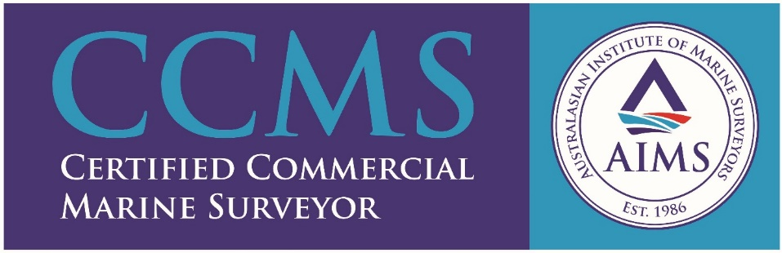

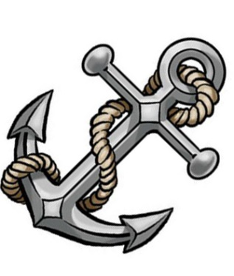
Jernertʼs Marine Investments Pty Ltd
Accredited under the new AMSA accreditation scheme for Commercial steel and aluminium vessels operating in Australian waters.
Accredited under the new AMSA accreditation scheme for electrical plan approvals and electrical surveys on Commercial vessels operating in Australian waters.
- Jernertʼs Marine Surveying Service founded in 2009, will provide a professional marine survey service for the maritime industry in Australia, and to help the industry in staying on top of the ever-changing marine legislation.
- Ensure vessel owners are treated in a professional way, and their interest is respected and protected from the public.
- Through effective management and proper professional development will ensure that stakeholders will benefit, to be able to provide a safe marine operation for their guests and workforce.

