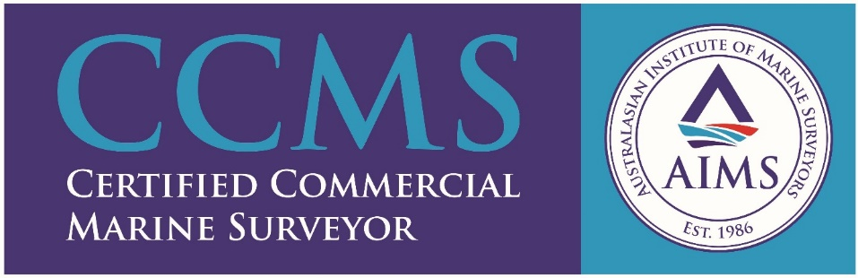

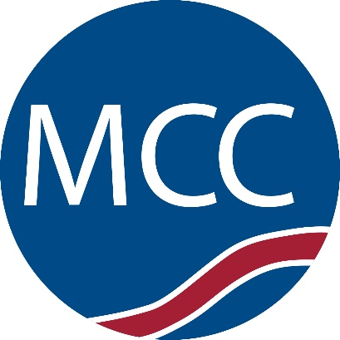
MCC Marine
The Maritime industry is an ever-changing affair, and in the modern era the pace of this change is only emphasized. The ability to adapt is unique and above all else crucial for a marine surveying company steaming toward the 2020’s.
MCC Marine as an institution is founded upon several core philosophies that have ensured its prosperity for the best part of three decades, including the aforementioned ability to adapt, a standard of efficiency that is brought to every job, and an added element of building client rapport.
MCC Marine takes pride in the diverse range of jobs that we can be contracted to complete. Bulk vessel surveys, cargo condition surveys, draught surveys, cargo securing reports and marine warranty surveys are just a few of the jobs that MCC frequently caters for to meet industry demand. Our new offshore transhipment loadmaster division is busy assisting clients both here in Australia and overseas.
Beyond this, our staff is an experienced and team from diverse industry backgrounds. They not only know the most efficient way to complete the job but go the extra mile wherever possible to ensure the specific needs of the client are always met.
Our clients know that the MCC Marine brand will not only get the job done, but get it done well and in a timely and cost-effective manner.

