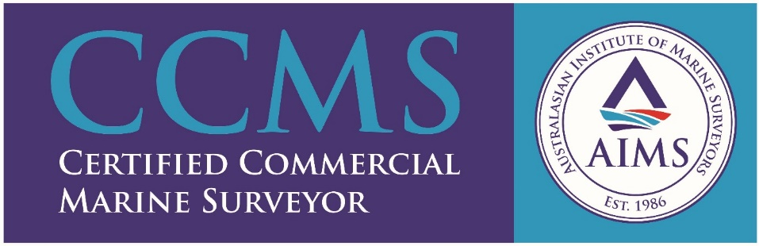
MER SOLUTIONS

MER Solutions is a multi-disciplinary professional practice offering specialist maritime and shipping industry solutions, risk management and representation.

Paul Mitchell
paul@mer-solutions.com
Mob +61 400 441230
MER Solutions Asia Pacific Pty Ltd
ACN 623 196 994
www.mer-solutions.com

