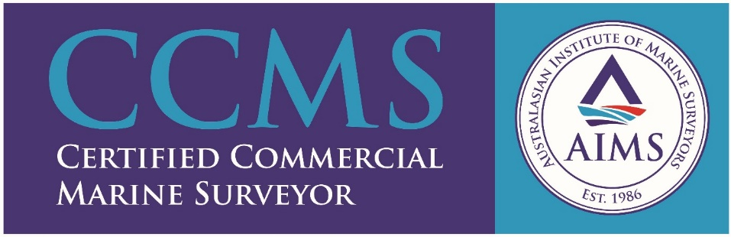

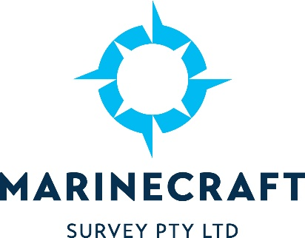

Marinecraft Survey Pty Ltd.

Marinecraft Survey is committed to providing the highest quality service to its clients. Our Surveyors each have over 25 years’ experience in the maritime industry, we are all current AMSA, Certificate of Competency, Class 1 Marine Engineers and still actively work on commercial vessels. When conducting surveys, we believe this close, ‘hands on’ involvement within the marine industry gives us a well-balanced and practicable approach to undertaking vessel surveys and helps to ensure the safe and efficient operation of both Domestic Commercial Vessels and Privately-operated vessels.
We are also AMSA Accredited Marine Surveyors and it is our objective to ensure that Domestic Commercial Vessels meet the requirements of the National Standards of Commercial Vessels. We encourage the vessels operators/owners to be involved during the Survey process to ensure the understanding and operation of safety, mechanical, and electrical equipment on board the vessel and promote a culture in safety and care for the environment within the industry.
Our business will also complete Condition Reports for pleasure craft seeking insurance or insurance renewals for their vessels. The Condition Report will list any observations, if any, that could be implemented on board to help ensure the vessel is in a sea worthy condition and insurable.
Nicholas Fleming 0488 252 104.
Nick Johnston 0419 842 563.
Sam Webb 0428 846 767.

