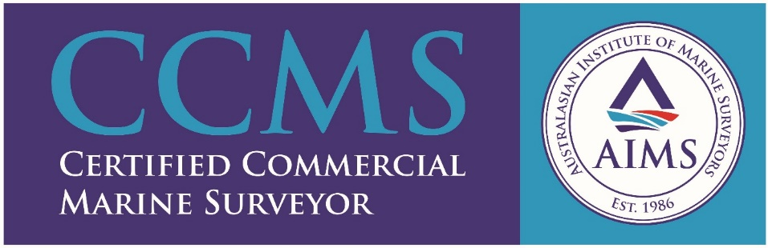
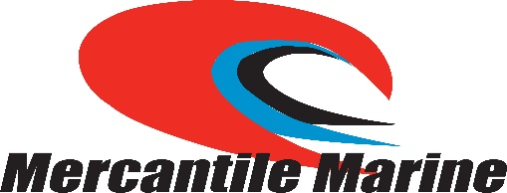

Mercantile Marine Pty Ltd
Mercantile Marine Pty Ltd was established in 2003, becoming the parent company of both WA Mercantile Services and Griffith WA Services.
WA Mercantile Services was incorporated in Fremantle in 1979, to provide ancillary shipping and marine insurance services to Western Australia. In 1985, WA Mercantile Services acquired the company Griffith WA Services, which was the Western Australia franchise from the Internationally recognised Inspection, Marine Surveying and Assay Group, then known as Daniel C Griffith & Co based in the UK.
Today Mercantile Marine has offices in both Geraldton and Bunbury, providing the following services to the marine industry in Western Australia.
- Marine Surveying: Draft Surveying, Ships Hold Surveying (cleanliness, suitability and water tightness), On and Off Hire Surveys and Bunker Surveys
- Small Vessel Survey: Survey and Valuations on Commercial and Recreational vessels, structural integrity, engineering and damage assessment for the insurance and banking industry.
- Ships Agency: Co-ordination of all loading activities and preparation of shipping documentation including export entries, Bills of Lading and Customs.
- Ship Brokering: Negotiation with ship owners and fixing full or part cargoes on behalf of Mining Clients.
- Stevedoring: Provision of suitably qualified staff for the loading and discharging of bulk cargo, bagged cargo and heavy lifts.
- Commodity Sampling and Moisture Determination: In accordance with Australian and ISO Standards.
- Laboratory: Specializing in Transportable Moisture Limit Analysis as per the IMSBC Code.
- Authorised Officers: Department of Agriculture and Water Resources qualified Authorized Officers for both samples and empty bulk carriers.

