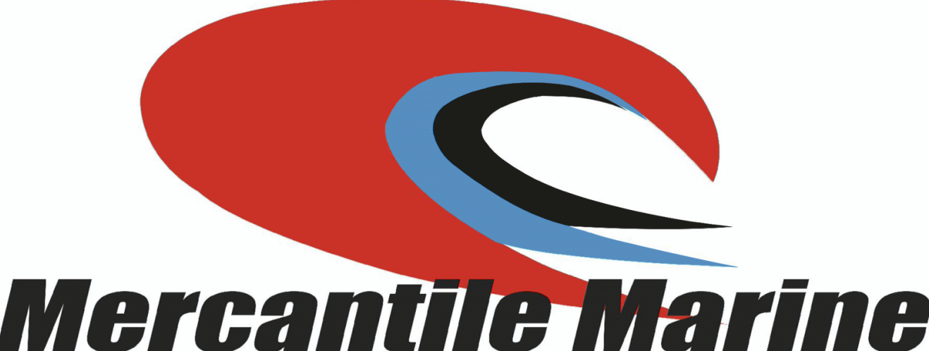

Our surveyors are members of the Australiasian Institute of Marine Surveyors, and are accredited to perform the following independent Marine Surveying Services and specialise in the following surveys:
- Grain Certified Marine Surveys.
- Department of Agriculture Authorised Officers for Empty Bulk Carriers, Grain, Woodchips, and Logs.
- Initial, Intermediate and Final Draft Surveys.
- Ships Hold Surveys for cleanliness and suitability for each particular commodity to be loaded.
- Survey of Ship and ships equipment to ensure they comply with the IMO Regulations and The Australian Marine Safety Authority’s regulations relative to the Charter Party conditions.
- Hose testing of ship’s hatch covers to establish water tightness.
- International Maritime Organisation Compliance Survey of both ships and shippers that are recognised by Marine Insurance Companies.
- Loss / Damage Cargo Surveys.
- On and Off Hire Surveys.
- Bunker Surveys.
- Small boat and fishing boat condition and valuation surveys for insurance.
- AMSA accredited fishing boat surveys.
We operate out of Geraldton and Bunbury, but also attend at outports from Melville Island in the North to Esperance in the South when required.

