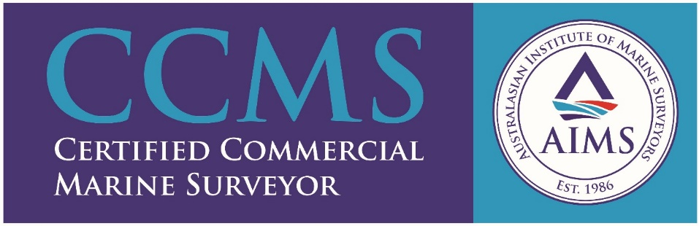

PROPEL MARINE

Propel Marine is a fully integrated marine surveying company, offering services across Australia and abroad.
We regard the professionalism of our personnel as the single most important factor in meeting the needs of our clients. Our highest priority is to meet or exceed your expectations on every single occasion.
With a wealth of local marine industry experience and surveying expertise, we are a group of Industry Leaders, Master Mariners, Marine Engineers and Experienced Marine Surveyors, all of whom are highly competent to undertake various surveys as per client requirements in line with industry standards.
The marine surveying services offered by Propel include:
- Hold advisory (Pre-inspection) for loading of any bulk cargo.
- Marine hold inspection for Grain.
- Authorised Officer (on behalf of ADAWR) inspection for grain at berth and anchorage.
- Draft surveys.
- On hire / Off hire bunker and condition surveys.
- Bunker stem surveys.
- Pre-purchase inspections.
- Break bulk loading and discharging survey.
- P & I club surveys, entry and re-entry inspections.
- AMSA pre-vetting inspection
- Port captaincy.
- Oil and Chemical Cargo calculations and surveys.
- Container damage surveys.

Coverage
Our team members are ideally positioned to cover all of Australia and the major international shipping hubs around the Asia Pacific region.

