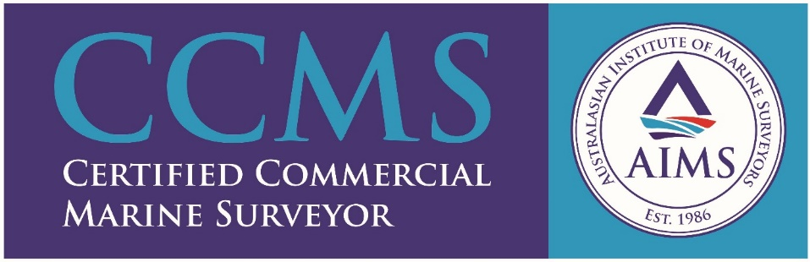

SHIP & CARGO SURVEYORS PTY LTD

As the name suggest, ships and their cargoes are our speciality. We attend at Melbourne Port, Geelong Port and Port of Portland and also interstate with prior arrangement. Overseas attendance requires ample notice.
The company is new, but the Operator have been in the maritime industry for a good 40 years. Started off in Singapore in 1975 as an apprentice and went on to command all types of vessels including offshore drilling rigs and drillships. Been in the Marine Surveying sector for the last ten years.
We professionally render the following services:
- Draught survey
- Bunker survey
- On/Off-Hire Condition survey
- Damage (vessel/cargo) survey
- Hold survey/inspection (Grain+Bulk cargo)
- Cargo Superintendent (load/discharge)
- Supervision –Hold cleaning(en-route)
- External AO (DAWR accredited)

CONTACT
Capt. Darbara Khosa
Mobile: 0411 523 918
Email: operations@shipncargosurveyors.com
Address: PO Box 274, Werribee, VIC 3030

