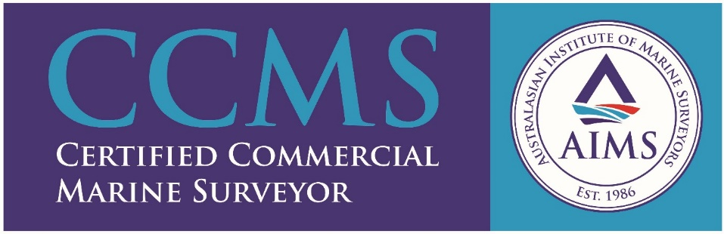

Strong Maritime Services

Strong Maritime Services have over 35 years’ experience in providing maritime consulting services to domestic and international clients.

We offer a complete range of maritime services: Capt Nelson Le Blond is one of the most trusted and established names in the industry experienced in shipping and consultant to senior management which includes Ports, Tug Operations, Training and tailored courses for shipping companies. He is a trained auditor with experience in shipping and transport industries.
We offer a wide range of services – Marine Consultancy, Ship Chartering & Brokerage, Damage Surveys, Cargo Inspections, Safety Audits, Marine Training, Towage Approvals & Maritime Investigations.

Expertise: Our unrivalled knowledge and experience enables us to respond efficiently to our customers. Having worked for major oil and gas, cargo and shipping companies in Australia and overseas we fully understand that regulations, port controls and customer priorities can differ in the international market. This enables us to provide the best solutions to our customers worldwide.
Our personalised service ensures that we tailor and meet our customer expectations yet remain competitive.
We remain up-to-date with shipping information; shipping legislation and our team are highly qualified with certification and membership of Australian and International Maritime Organisations.
We provide technical and operational expertise for our customers within the shipping, transportation and maritime, mining and construction industries.

For full details refer to our website www.strongmaritimeservices.com.au

Phone: +61 7 3012 6368
Email: enquiries@strongmaritimeservices.com.au
Address: One One One, 111 Eagle Street, Level 54, Brisbane, 4000

